XXⅡ International congress of History of Science, 24-30 July 2005 Beijing
The Transition of Land-Scaling System in Ancient East Asia
Gyeonbsang National University
Inviting Professor Hiroshi ARAI
1. Introduction
The linear scaling system before 8th C both in Korea and Japan had not been made clear for a long time. However, recently a scale unit named Kokanshaku (古韓尺: 26.7cm) was restored inductively by computer analysis for a lot of ruins such as old mounds, temples, palaces and so on ¹⁾. Moreover this Kokanshaku was verified from old documents such as the stone-monuments of Namsan-sinseon(南山新城) at 6th C in Korea ²⁾, Izumo-Fudoki(出雲風土記) compiled at 8th C in Japan ³⁾ and the articles on old Silla capital in Samgug-sagi (三国史記) compiled at 11th C ⁴⁾.
In addition, the ancient Korean land system i.e. Gyeolbu-je (結負制) was restored from the analysis of some old documents by intermediation of Kokanshaku. The results clearly showed that the Gyeolbu-je had adopted the decimal land scaling system i.e. chong(井,丁) = 10 gyeol(結), gyeol = 100 bu(負), bu = 10 sog(束) and sog = 10 pa(把). As chong was square ri(li里) and ri was 300 bo(bu歩) in ancient east Asia, sog was calculated to be 9 square bo i.e.( 3 bo×3 bo).. Therefore Gyeolbu-je used 3 bo as the basic land-scaling unit, i.e. Ryangjonbo(量田歩), where bo consisted of 6 Kokanshaku. From the above discussion Korean Gyeolbu-je is summarized as follows..
Kokanshaku = 26.7 cm, bo = 26.7 cm×6=1.60 m, Ryangjonbo = 1.60 m×3 = 4.80 m
ri = 1.60 m×300 = 480 m, sog = 23.0㎡, chong = 230,000㎡..
On the other hand, the ancient Japanese land system. i.e. Daisei(代制) was unclear in detail except that the area of sokushiro(束代) was known as 23.0㎡. However today, it became clear that the area of sokushiro agreed with that of sog accurately and the Chinese character of sokushiro(束代) also agreed with that of sog(束). This coincidence strongly suggests us the Japanese Daisei was originated from the Korean Gyeolbu-je ⁵⁾.
If so, there might be some evidences that Ryangjonbo(4.80m) was used in the planning of large-scale old mounds in Japan. From this viewpoint a lot of large-scale mounds in good shape or well surveyed by excavation were examined. The results showed good fitability, for example the largest Nintoku-Ryo(仁徳陵) is just 100 Ryangjonbo in length and the followings are 90, 75, 60 Rangjonbo and so on ⁶⁾.
From the above consideration, in this paper we can discuss the transition of land-scaling system in ancient east Asia, because the Chinese old text Liji(禮記) said that the linear scaling system in the Zhou(周) dynasty was that the Zhou-yard(周歩) consisted of 8 Zhou-foot(周尺) i.e. Zhou-yard = 20 cm×8 = 1.60 m agrees well with the bo(歩) in Gyeolbu-je or Daisei.

2. Example of Kokanshaku (古韓尺)
2-1 Representative constructions planned by Kokanshaku
Kokanshaku (古韓尺: 26.7cm) was restored inductively by computer analysis for a lot of ruins such as old mounds, temples, palaces and so on. The typical examples of construction planned by Kokanshaku are shown in Table 1, Table 2 and Table 3 ¹⁾ ⁶⁾.

2-2 Representative documents indicating Kokanshaku
Kokanshaku has been verified also from old documents such as the stone monuments of Namsan-sinseon(南山新城) at 6th C in Korea, Izumo-Fudoki(出雲風土記) compiled at 8th C in Japan and the articles on the old Silla capital in Samgug-sagi (三国史記) compiled at 11th C.
    - Stone monuments in Namsan-sinseon(南山新城) ²⁾
Namsan-sinseon located in the southern part of Gyeongju (慶州) in Korea was a mountain castle surrounded by 3.7km rampart. From there, eight pieces of stone-monuments concerning to the castle wall construction had been unearthed, and the three of them recorded the sector lengths of the wall construction as follows.
No.1 11 bo(歩) 3 chog(尺) 8 chi(寸) → 69.8 chog(尺)
No.2 7 bo(歩) 4 chog(尺) → 46.0 chog(尺)
No.3 21 bo(歩) 1 chi(寸) → 126.1 chog(尺)
The rampart wall is several meters in thickness and is not straight. Comparing with the length (for example 20 bo 1 chog), the minimum expression (for example 1 chi) is too minute to go well with. Moreover their three values have proportional relation, 10.5 : 7.0 : 19.0 each other. They must have been converted from some scale unit i.e. Kokanshaku to Chinese Jin-foot(晋尺：24.3cm) as follows.
No.1 69.8×24.3 / (10.5×6) = 26.8cm
No.2 46.0×24.3 / ( 7.0×6) = 26.6cm
No.3 126.1×24.3 /(19.0×6) = 26.9cm
These three calculated values are in good agreement with Kokanshaku.
2-2-2 Izumo-fudoki (出雲風土記) ³⁾
Izumo-fudoki, compiled at 733A.D states very minute geography of Izumo district. . If we would follow faithfully the description, we could reproduce the detail map.
In Izumo-fudoki, there are quite strange expressions shown as follows.
From Izumo(出雲) office to Sazau(佐雑) village 13 ri(里) 64 bo(歩)
From Kamdo(神戸) office to mountain Kage(陰) 5 ri(里) 86 bo(歩)
Circumference of lake Kamdo(神戸) 35 ri(里) 74 bo(歩)
These numeral values are too minute to go well with just like as Namsan-sinseon. They must have been converted from another scale unit. Then we can get the conversion rule from old Kokanshaku to new Tenpyo-foot(天平尺＝唐尺) as follows.
Kokanshaku-yard (bo歩) = Tenpyo-yard (bo歩)／0.881
From the above formula Kokanshaku is derived to be 26.4cm if we put Tenpyo-foot to be 30.0cm. Conversion results are shown in Table 4.
2-2-3 Sangug-Sagi (三国史記) ⁴⁾
Samgug-sagi compiled at 11th C states the grid planning of the old Silla capital as 3075 yard(bo歩) in length and 3018 yard(bo) in width, each strongly suggests 10 ri(里=300 bo) plus road space. On the other hand, incidentally one block length of the grid in the old Silla capital is now given as 160m by recent archaeological researches. Therefore this grid 160m is directly corresponding to 100 bo and from this relation, 1 bo is calculated to be 1.60m, 1 foot is to be 26.7cm. This length agrees very well with Kokanshaku.
Fig. 1 shows the grid planning of the old Silla capital restored by Kokanshaku.
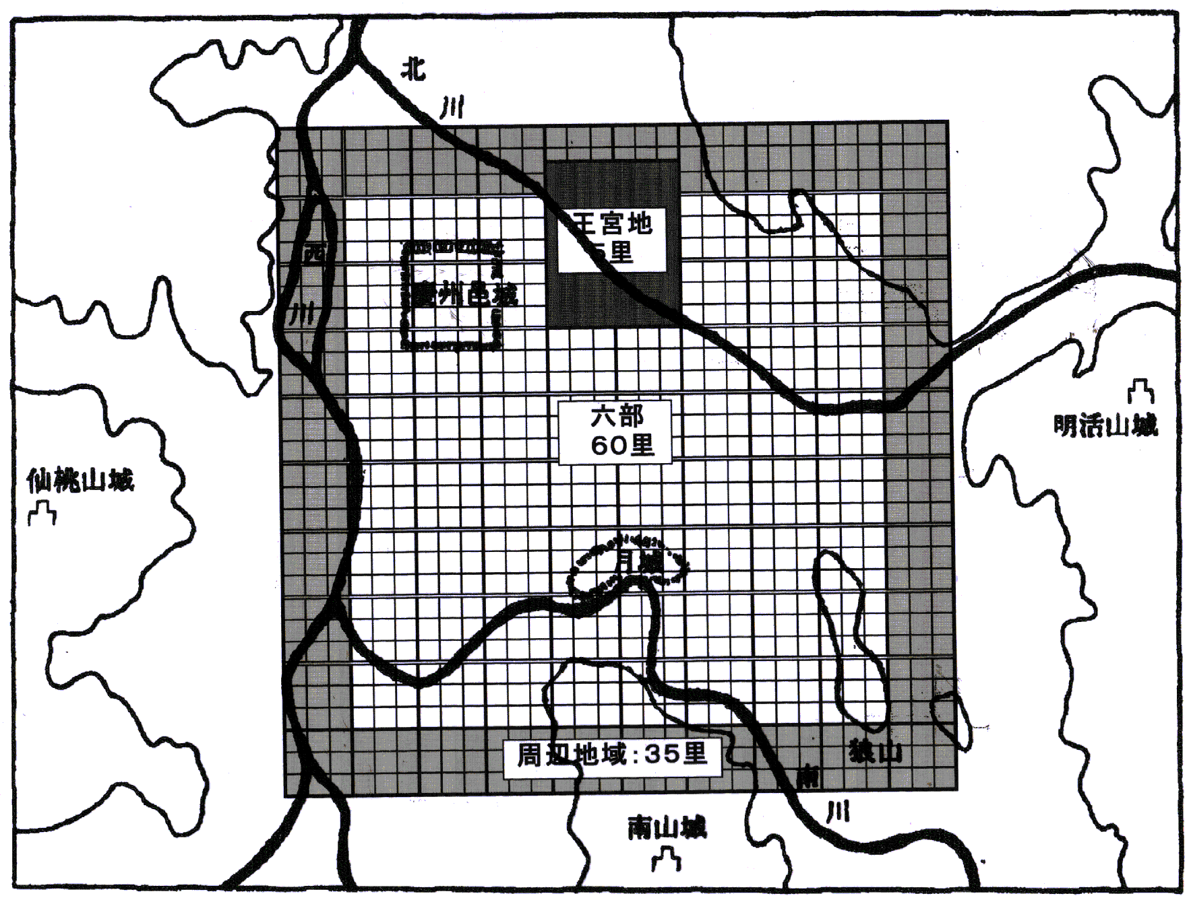

Fig.1 The old Silla capital restored by Sangug-sagi and Kokanshaku
3. Korean Gyeolbu-je (結負制) and Japanese Dai-sei (代制) ⁵⁾
It is well known that both Gyeongmu-je(頃畝制) on the basis of real farm area and Gyeolbu-je(結負制) on the basis of harvest had been carried out simultaneously in Korea but even the real area before Goryeo(高麗) has not been clear yet, mainly because of miss-writing in a basic document Munjong Ryangjeon rule(文宗量田法).
However the miss-writing is now corrected by referring to Goryedogyeong (高麗図経) and it becomes clear that Ryangjonbo(量田歩) consists of 3 bo(歩) and Gyeol (結) is defined as square 33 Ryangjonbo(量田歩). This means Gyeol (結) is square 100 (99) bo (歩) i.e. Gyeong (頃).
The remained question is why they introduced so a complicated system that Gyeol is square 33 Ryangjonbo. The answer came from the Sungboksa (崇福寺) inscription in which Gyeol (結) was regarded as 9,000 square bo (歩). This means sog(束) was defined as square Ryangjonbo, because Gyeol (結) is 1,000 sog(束). Gyeol (結) was not equal to Gyeong (頃) in Silla(新羅) period, while they agreed with each other in Goryeo period.
As well known, in ancient China jing(井) meant square li(里) i.e. 90,000 square bo (歩) since li consisted of 300 bo(歩). Consequently chong(jing井) agreed with 10 Gyeol (結). The result clearly showed that the Gyeolbu-je had adopted the decimal land scaling system i.e. chong(井) = 10 gyeol(結), gyeol = 100 bu(負), bu = 10 sog(束) and sog = 10 pa(把) and sog(束) i.e. square Ryangjonbo(量田歩) was the basic land scaling unit in ancient Gyeolbu-je(結負制).
From the above discussion Korean Gyeolbu-je is summarized as follows..
Kokanshaku = 26.7 cm, bo =1.60 m, Ryangjonbo = 4.80 m, ri = 480 m,
sog = 23.0㎡, gyeol = 23,000㎡, chong = 230,000㎡. Gyeong=25,600㎡
On the other hand, the ancient Japanese land system i.e. Daisei(代制) had been unclear in detail except that the area of sokushiro(束代) was known as 23.0㎡. However today, it became clear that the area of sokushiro agreed with that of sog accurately and the Chinese character of sokushiro also agreed with that of sog. This coincidence strongly suggested us the Japanese Daisei was originated from the Korean Gyeolbu-je.

4. Large-scale old mounds designed by Ryangjonbo(量田歩) ⁶⁾
If the Japanese Daisei(代制) was originated from Korean Gyeolbu-je, there might be some evidences that Ryangjonbo(4.80m) was used in the planning of large-scale old mounds in Japan. From this viewpoint a lot of large-scale mounds in good shape or well surveyed by excavation were examined. The results showed good fitability, for example the largest Nintoku-Ryo(仁徳陵) is just 100 Ryangjonbo in length and the followings are 90, 75, 60 Ryangjonbo and so on. The 28 largest old mounds are summarized in Table 5.

5. Transition of land-scaling system in ancient east
The Chinese old text Liji(禮記) said that the linear scaling system in the Zhou(周) dynasty was that the Zhou-yard(周歩) consisted of 8 Zhou-foot(周尺). The original text is as follows.
禮記 王制篇
①古者 以周尺八尺為歩 ②今以周尺六尺四寸為歩
③古者百畝 当今東田百四十六畝三十歩
④古者百里 当百二十一里六十歩四尺二寸二分
The following part ② means the old Zhou-yard (8 Zhou-foot) was equal to the new 6.4 foots (chi尺), ③ means the old 100 mu(畝) was equal to the new 146 mu(畝) 30 bu(歩), and ④ means the old 100 li(里) was equal to the new 121 li(里) 60 bu(歩) 4 chi(尺) 2 cun(寸) 2 fen(分).
③ and ④ should be the conversion results from 8 Zhou-feet to 6.4 new feet but they do not agree with each other. This is , as Kong Guangsen(孔廣森) ⁷⁾ had pointed out, because that “6.4 feet” was miss writing of “6.6 feet”. If we adopt this opinion, the calculation result of ④ turned out to be 121 li(里) 63 bu(歩) chi(尺) 2 cun(寸) 2 fen(分) which agrees very well, though there is slight difference.
It is generally accepted that the Liji(禮記) was written in Tai(秦) or Xihan(西漢) dynasty. Therefore the Han-foot(漢尺:23.5cm) must have been used as the new scale. So, we can get Zhou-foot(周尺) was 19.4cm (23.5cm×6.6 / 8).
Concerning to Zhou-foot(周尺), Wu Dacheng(呉大澂) ⁸⁾ restored it as 19.6cm and Wu Chengluo(呉承洛) ⁹⁾ restored it as 19.8cm from relics of Zhou(周) dynasty Here we adopt 19.8cm as Zhou-foot(周尺). From the above discussion the ancient land scaling system in China is summarized as follows..
Zhou-foot(周尺) =19.8 cm, Zhou-yard(周歩) =1.585 m, Zhou-li(周里) = 476 m
Zhou-jing(周井)= 227,000㎡. Zhou-qing(周頃)=25,100㎡
These results quite well agree with Korean ancient Gyeolbu-je(結負制) and Gyeongmu-je(頃畝制). This coincidence strongly suggested us the Korean Gyeolbu-je and Gyeongmu-je were originated from the ancient land scaling system in China. Consequently we can get the transition diagram of the ancient Asian land system as shown in Fig.2.

7. Conclusion
- Japanese ancient land system Daisei(代制) completely agreed with Korean ancient land system Gyeolbu-je (結負制). This coincidence strongly suggested us the Japanese Daisei was originated from the Korean Gyeolbu-je.
- According to the Chinese old text Liji(禮記), in Zhou(周) dynasty, Zhou-yard(歩) was 1.585 m, li(里) was 476 m, jing(井) was 227,000㎡ and qing(頃) was 25,100㎡. On the other hand in the ancient Korean Gyeolbu-je and Gyeongmu-je(頃畝制), yard(bu歩) was 1.60 m, ri(里) was 480 m, chong(jing井) was 231,000㎡ and qing(頃) was 25,600㎡. This similarity also strongly suggests us the Korean land system was originated from the Chinese land system in Zhou dynasty.

Reference
- Hiroshi ARAI, An investigation on restoration method of ancient linear measure, The 6th International Congress for Historical Metrology, Lillie, France, October 1992. Cahiers de Metrologies, tomes 11-12(1993-1994). This report is the summary of the three articles written in Japanese. (English)
H.ARAI, Kodai shakudofukugenhou no kenkyu(1-3), Bulletin of the Society of Historical Metrology, Japan, 13－15、1990－1992 (Japanese)

H.ARAI Maboroshi no Kodaishaku, Yoshikawa-kobunkan, Tokyo,1992 (Japanese)
(2) Hiroshi ARAI, On former scale Kokanshaku verified from ancient Asian documents, Ⅶthe International Congress for Historical Metrology 26th September, 1997, Siege, Germany (English)
(3) H.ARAI, Kohan-scale (an old Korean scale) revealed in the mileage description of Izumo-Fudoki, Paekche Yongu, 37,2003 (Korean)
(4) H.ARAI, Restoration of Silla capital and Kohan scale (an old Korean scale) Considering articles in Samguksagi and Samgukyusa, The Paekche Yonku, 36, 2002 (Korean)
(5) H.ARAI, The Restoration of Korean Ancient Gyeolbu-je and the Origin of JapaneseDai-sei, The Journal of Korean Ancient History, 30，2003（Korean）
(6) H.ARAI, Meassureing Unit of Japanese Tumulus Design and Japanese Dai-sei / Korean Gyeolbu-je, KOKOGAKU ZASSHI, 88-3，2004 (Japanese)
(7) 孔廣森［禮學卮言・小載戴禮記］『皇清経解』巻696 (Chinese)
(8) 呉大澂『権衡度量実験考』羅振玉、1915, p.134 (Chinese)
(9) 呉承洛『中国度量衡史』商務印書館、1937, p.41-46 (Chinese)

