ON CRITERION FOR SMELTING OR REFINING SLAG
IN ANCIENT IRON MAKING

Hiroshi ARAI , Bo-Young HUR¹, Shiro BANYA²
¹Gyeongsang National University, Gyeognamdo 660-701, Korea
²Metals Museum, The Japan Institute of Metals, Sendai, Japan

ABSTRACT

The iron-use in Japan started at the late Jomon period(B.C.3rd C), but we must wait until 800 years later, the late Kofun period(AD.6th C) for the adequate evidence of the iron smelting, because all excavated slags of these periods are judged as refining or forging ones. However this situation is anomalous from the view point of the world-wide history.
In this paper, we discussed about the criterion comparing with Europe situation, smelting restoration tests and thermodynamic consideration. The results are as follows.
(1) There is some difference on the criterion for slag between in Japan and in Europe. The slags containing SiO₂ less than 25% are always judged as refining or forging ones without exception in Japan, but are often judged as smelting ones in Europe. (2) The slags in smelting restoration tests also often show SiO₂ less than 25% (3) The thermodynamic consideration derives that SiO₂ in a primitive smelting slag is apt to stay up to 25% . (4) We can utilize minor elements such as Co for judging slag. (5) Consequently we can not easily deny the iron making in Yayoi period.

- Introduction
The iron-use in Japan started at the late Jomon period(B.C.3rd C). But concerning the adequate evidence of the iron making in Japan we must wait until 800 years later, the late Kofun period(AD.6th C), because all excavated slags of these periods are judged as refining or forging ones. However this situation is anomalous from the view point of world-wide history. Is the criterion of judging slag type really proper ?
We know there is some difference on criterion between in Japan and in Europe. The criterion should be discussed under taking consideration of the smelting conditions (furnace type, temperature so on) and the raw material conditions. We should investigate more generalized criterion under thermodynamic consideration. After these considerations we would like to discuss the judgment of the Yayoi and early/middle Kofun period slags by the new criterion.

2. Judging slag in Japan
There are many slag samples chemically analyzed and judged their type in Japan, which were mainly carried out by M.Osawa and National Museum of History and folklore.
First of all, we shall briefly look up and summarize M.Osawa’s valuable data [1]. As there are so many his original reports on the iron slag analysis, we picked out only the data which contain TiO₂ less than 1%, because the cases of containing TiO₂ more than 1% are no doubt to be smelting slags. The comparisons between the chemical composition (SiO₂, Total Fe) and his judgment of the slag type are shown in Fig.1 and Fig.2.
What is evident from the figures is that the slags containing SiO₂ less than 25% or containing Total Fe more than 48% are always judged as refining or forging ones without exception. Of course though M.Osawa has been judging the type of the slags not only by the chemical composition but also by the micro structure or the unearthed condition, the most important factor is the chemical composition without doubt.

3. Judging slag in Europe
On the other hand, in order to know how the judgment of slag type has been carried out in Europe, we collected the cases [2] and compared them with Japanese judgment as shown in Fig.3 and Fig.4. Anyway the situation quite differs from Japan.
The slags judged as smelting ones in Japan always contain SiO₂ more than 25% or contain Total Fe less than 48% without exception but more than half of the smelting slags in Europe contain SiO₂ less than 25% or contain Total Fe more than 48%.
Therefore it is said that the smelting slag in Europe may include some refining slags. Of course we can not deny the risk but we should not discard the data easily. As a matter of fact, even in Japan, the smelting slag in Furuhashi site which is one of the earliest iron-making spot contains only 18% of the SiO₂ [3].

4. Slag in smelting restoration tests
We can find a few restoration tests of primitive iron smelting in Europe [4] and in Japan [5]. The greater parts of the slag contain SiO₂ less than 25% or Total Fe more than 48% as shown in Fig.5 together. The temperature of iron smelting in primitive stage was generally lower than the following period, which is apt to bring insufficient ore reduction, that is, higher Total Fe and lower SiO₂ .

5. Thermodynamic consideration
Concerning the smelting slag or refining slag, let us study thermodynamically on the FeO-Fe₂O₃-SiO₂ diagram shown in Fig.6.
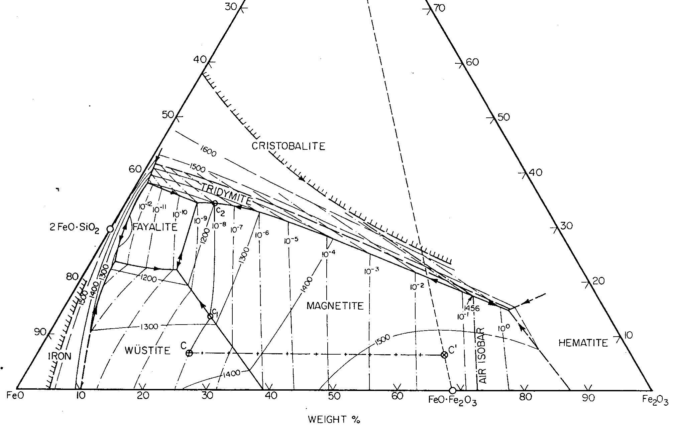
Ａ
Ｂ
Ｃ
Ｄ
Fig.6 FeO-Fe₂O₃-SiO₂ diagram and iron ore reduction route

Generally speaking, the composition of iron ores is in existence around the point A on the diagram. When the reduction is executed, the composition is moving toward the point B and starts to take place the iron precipitation. Of course this first coming iron is solid state because of its low carbon in other words high melting temperature. When beginning iron deposition, the composition of the ore side moves toward the point C and reaches its melting point. The melt down oxides are the first coming smelting slags that are lower in SiO₂. Of course we must also think about the participation of furnace material etc to slag composition but there would not be much difference basically. In the primitive smelting stage, the slag composition is apt to stay in this low SiO₂ area.
However proceeding the reduction further more, the iron reduced from ores absorbs carbon from the white heated charcoal or the atmosphere and partially melt down due to the lowering its melting point and finally the slag composition reaches point D which is higher in SiO₂. That is, the smelting slag composition largely depends on the historical developing stage.
Next let us pay attention to the oxygen potential of the slag. The smelting slags are formed in the reducing atmosphere while the refining slag is formed in the oxidizing one. This should be reflected in the composition ratio of FeO and Fe₂O₃ in the slags. In fact, Fig.7 which is corresponding to Fig.1 and Fig.2 shows such general tendency. However the smelting slag in Europe shows different region as shown in Fig.8. There is still big discrepancy between in Japan and in Europe..

- New view point
Generally speaking minor elements in iron ores are divided into two groups so that one is enriched to the smelting slag side and another is enriched to the metallic iron side(or indirectly to the refining slag). That is, Cu, Ni, Co, As, Sb, W and so on concentrate into the refining slag side while Ti, V, Ca, Na, Al and so on remain in the smelting slag side. Therefore trace of minor elements behavior would be useful for the judging type of the slag. Fortunately National Museum of History and folklore reported the neutron activation analysis of various minor elements for many iron slags [6]. Among various elements we took notice of Co because Co content in iron ore is rather stable and its enriching into the metallic iron side is remarkable. Table 1 shows the distribution of Co in the iron ores, smelting slag and refining slag in the above report and Table 2 shows some experimental results on the Co behavior during smelting testing process[7].

Table1 Co (ppm) distribution in ore and slag
Unfortunately at now we are not free from misjudging slag types. Therefore we must utilize everything we can refer to. If Co value is extremely high in slag, there is a possibility that the slags are as refining ones even if judged as the smelting ones and if Co value is extremely low, there is a possibility that the slags is smelting ones even if judged as the refining ones.
Co  (ppm) | Iron  ore | Iron  sand | Smelting slag |  | Refining  slag
Co  (ppm) | Iron  ore | Iron  sand | Iron ore | Iron sand | Refining  slag
0～6 |  |  | 14 | 12 | 4
7～12 | 3 |  | 8 | 12 | 12
13～25 | 2 |  | 6 | 14 | 24
26～50 | 3 | 2 | 3 | 5 | 18
51～100 | 2 | 4 |  | 3 | 20
101～200 |  | 9 |  | 3 | 13
201～400
401～800 |  |  |  |  | 2

Table2 Change Co (ppm) in smelting test
In this way, we picked up only the reliable judgment slag from the above report and made a diagram as shown in Fig.9. This can be used as a new criterion for judging slag. We can point out that the smelting slag area is enlarged to higher FeO side compared with the old one shown in Fig.7.
Test places | Ina | Katano | Katano
Iron ore | 26 | 33 | 48
Reduced iron | 75 | 65 | 85
Smelting slag | 4 | 2 | 5

- Application of new criterion for earlier period (Yayoi etc) slag
The new judging criterion was applied to Yayoi and early/middle Kofun period slag that all of them are not recognized as smelting one up to now. As a result, 9 data among 16 data showed the possibility to be the smelting slags as shown in Fig.10.
Therefore we can not easily deny the iron making in Yayoi or early/middle Kobun period. We should investigate more generalized criterion under the thermodynamic consideration.

8. Korean slag
It is no doubt that the ancient iron making technology in Japan was greatly influenced from Korea. We would like to make it clear how the technology transfer was taken place through the investigation of the iron slag excavated in Korea and in Japan.
For the purpose we tried to apply the new judging criterion for the ancient slag in Korea. Up to now there are rather many chemical analysis data for the excavated iron in Korea but the chemical analysis of the excavated slag in Korea or China are very few compared with Japan. Fig.11 shows the relation between the ruin slag compositions and the slag type judgment in Korea on the new criterion diagram[8].
It seems there is no problem if we judge the Korean slag by the new criterion. Especially the smelting slag mentioned by double circle mark in the figure (Milyang site)[9] is very much interesting because the similar composition slag has not found in Japan yet, which support strongly the new criterion.

REFERENCES
- M.Osawa; Nihon Seitetsu Shiron, (1983), 85-164.
M.Osawa; Nagano A Iseki, (1987).
M.Osawa; Tatara Kenkyu, No.29, (1988),21-34.
M.Osawa; Nihon Kodai no Tetsu Seisan, (1991), 164-191.
- K.Kubota; Nihon Seitetsu Shiron, (1983), 85-164.
R.F.Tylecote; A History of Metallurgy, The metal society, (1979), 40-63.
G.R.Morton and J.Wingrove, JISI, (1959), 1556-1561.
W.Oelsen and E.Schurmann, Archiv fur das Eisenhutten.,(1954), 507-514.
3. S.Takatsuka et al, Kokogaku to Shizenkagaku, No.35, (1997), 1-5.
- J.W.Gilles, Stahl und Eisen, 78, (1958), s.1690.
K.Hasegawa, Tatara Kenkyu, No.12, (1965), 1-12.
- S.Yokokawa, Tatara Kenkyu, No.19.20, (1979), 1-11.
- S.Hirai et al, Kokuritsu Rekishi Minzoku Hakubutsukan Hokoku, No.58, (1994).
- S.Hirai et al, Shakai Tekko Kogaku Bukai E Forum (ISIJ), (1999), 59-60. etc.
- Dongsuk Yoon, Memorial collected papers of Prof. WonYong Kim retirement, (1987), 380-390.
M.Osawa, Melting furnace ruin in Gyeongju Hwangsongdong 524-9, (1999),84-106. etc.
- Unpublished analysis by Kokuritsu Rekishi Minzoku Hakubutsukan, Smelting ruin in Milyang Sachonri (Excavated by Gyonghae Museum).

